Automatic Number Plate Recognition (ANPR)

**DEPARTMENT OF ARTIFICIAL INTELLIGENCE &**

**DATA SCIENCE**

# Abstract

Automatic Number Plate Recognition (ANPR) systems play a crucial role in modern traffic control and surveillance infrastructure. These systems leverage computer vision and optical character recognition (OCR) technologies to automatically detect and extract vehicle

registration numbers from images or video feeds. The implementation described utilizes OpenCV for image preprocessing and Tesseract OCR for textual interpretation, facilitating real-time identification of license plates. Additionally, the system maps the initial characters of each plate to specific geographic regions, allowing it to determine the state of vehicle registration. This feature proves highly valuable in applications such as automated toll collection, parking enforcement, and traffic law monitoring. Designed for efficiency,

accuracy, and adaptability across diverse environmental conditions, the system offers a reliable and scalable solution for real-world deployment.

Advancements in smart vehicle technologies and Intelligent Transportation Systems (ITS) continue to transform many facets of daily life. This paper provides a comprehensive review of the latest methods and innovations in ANPR systems, along with a comparative analysis of performance across various real-time and simulated algorithms, including those driven by computer vision. ANPR systems recognize vehicles based on their license plates using

specialized recognition techniques. However, despite advancements in algorithms, achieving optimal accuracy often requires dedicated hardware enhancements. Factors such as plate condition, non-standardized formats, complex backgrounds, camera quality and angle, image distortions, motion blur, lighting variations, memory or processing limitations, and environmental variables can significantly affect performance. These challenges make ANPR a dynamic and compelling research area. With the rise of the Internet of Things (IoT), ITS is evolving rapidly, and integrating ANPR with technologies like RFID, GPS, and mobile platforms offers promising avenues for improvement. Furthermore, deep learning methods have increasingly enhanced detection capabilities within the computer vision domain. This research aims to contribute to the growing body of knowledge in ITS and ANPR by reviewing key literature, evaluating extraction, segmentation, and recognition techniques, and offering insights into future research directions.

# Introduction

Automatic Number Plate Recognition (ANPR) has become an integral part of daily life and is expected to remain essential as transportation systems evolve. With the emergence of autonomous vehicles, fundamental changes in transport infrastructure are becoming

increasingly possible, and ANPR is already playing a significant role in supporting intelligent

transportation systems by reducing or eliminating the need for manual intervention. Once limited to fixed roadside cameras or entry barriers, ANPR technology has evolved into mobile and handheld formats, thanks to advancements in smartphone technology. Its affordability and ease of deployment make it a popular choice in applications such as toll collection and parking management, especially since it does not require additional

transponders—unlike Ultra High Frequency Radio Frequency Identification (UHF-RFID) systems.

As urbanization accelerates and more people move from rural to urban areas, traffic congestion becomes a growing concern. Often, local governments are unprepared for the mobility demands of both residents and visitors. ANPR systems are increasingly employed to monitor and manage traffic flow, aiding in the implementation of intelligent transport

networks.

Modern ANPR cameras offer more than just license plate recognition; they can also capture data such as vehicle count, direction of travel, vehicle grouping, and speed. Their capacity to process large volumes of fast-moving vehicles has integrated them into numerous facets of digital infrastructure. Despite coming in various forms, all ANPR systems share the core function of accurately reading vehicle license plates without human involvement. These

systems are widely used in access control, automated parking, electronic tolling, billing systems, delivery tracking, traffic regulation, law enforcement, red light and lane

enforcement, queue management, and customer support services, among others [2–8]. Figure 1 illustrates a basic schematic of both fixed and mobile ANPR systems.

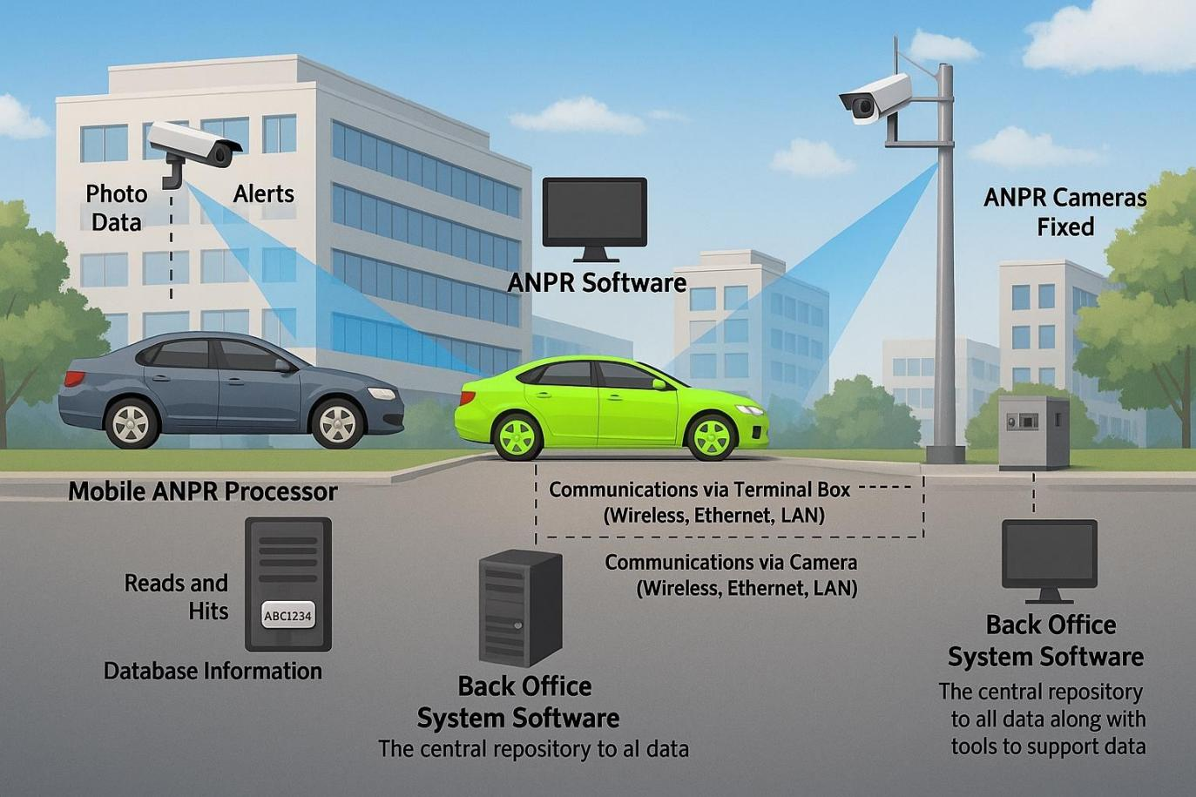

# Problem Description

Issues with Conventional Vehicle Monitoring Systems

Traditional approaches to vehicle identification, such as relying on manual observation or paper-based records, come with significant limitations:

1. Inefficiency: Manual tracking methods are slow and often result in missed or incomplete information.
2. Human Error: Mistakes in manual data entry or misinterpretation of number plates can lead to incorrect records.
3. Security Vulnerabilities: Unauthorized vehicles may easily bypass security checkpoints if human oversight is insufficient or inconsistent.
4. Scalability Issues: Systems that depend on manual processes are not practical for handling large-scale traffic in densely populated urban areas.

## The Need for Automation

As traffic volumes continue to rise, there is an urgent demand for more efficient and scalable solutions. Automated Number Plate Recognition (NPR) systems address many of these challenges:

1. Instant Identification: Number plates can be detected and logged in real-time, ensuring timely updates.
2. Reduced Human Involvement: Automation minimizes the need for manual input, significantly lowering the risk of errors.
3. Enhanced Precision: Automated systems provide a higher level of accuracy and reliability in identifying vehicles.

## Challenges in Developing an Effective System

While NPR systems offer numerous advantages, their development comes with several hurdles:

1. Accuracy Concerns: Variations in number plate formats, lighting conditions, and camera angles can impact the system's ability to detect plates accurately.
2. Processing Speed: For real-time applications, the system must analyze video frames rapidly without delays.
3. Environmental Factors: Adverse weather conditions, nighttime visibility, and fluctuating traffic speeds add complexity to the detection process.
4. Technical Complexity: Extracting meaningful information from video frames across diverse environments requires sophisticated computer vision techniques and meticulous fine- tuning.

# Project Objective

This project aims to create a real-time number plate detection system using OpenCV. The system will identify vehicle number plates from video frames captured by surveillance cameras. It will prioritize accuracy, speed, and resilience to environmental factors, ensuring its practical application in law enforcement, traffic management, and security scenarios.

## Current Systems

Existing Approaches for Number Plate Recognition

Several systems have already been developed to automate the process of number plate detection. These include:

1. Basic NPR Systems: Many existing systems rely on static images or low-quality video footage, employing fundamental techniques like edge detection or template matching. While these methods perform adequately under ideal conditions, they struggle with diverse environments and moving vehicles.
2. Advanced NPR Systems: More sophisticated systems leverage machine learning

techniques, such as Convolutional Neural Networks (CNNs), to achieve superior accuracy in number plate recognition. Although these systems require greater computational resources and extensive training datasets, they deliver enhanced performance across varying lighting and angle conditions.

## Workflow of Traditional Systems

Camera Capture: The system captures either a single frame or a sequence of frames from the video feed.

Pre-processing: The image is enhanced (converted to grayscale, noise reduction applied, and edge detection performed) to prepare it for plate detection.

Plate Detection: Regions resembling number plates are identified based on contours and aspect ratios.

Manual/Database Entry: In traditional setups, the results are often manually reviewed or recorded into databases.

# Proposed Solution

## Overview of the Suggested System

The proposed system builds upon existing solutions by introducing real-time detection capabilities and fully automated number plate recognition.

Key enhancements include:

Real-Time Processing: The system continuously captures video frames and processes them instantly to detect number plates as vehicles pass by.

Automatic Detection: Number plates are identified and displayed without any manual intervention, reducing the likelihood of errors.

-Database Integration: Detected plates can be stored and cross-referenced against existing databases for security purposes, such as identifying stolen vehicles or unauthorized access.

## Workflow of the Proposed System

Real-Time Processing: The system captures frames from live video feeds and processes them in real-time to detect number plates.

Number Plate Detection: Advanced image processing techniques, such as edge detection and contour filtering, are used to identify potential number plates.

Database Interaction: Optionally, detected plates can be matched against a database for validation purposes (e.g., flagging stolen vehicles).

Alert Mechanism: If an unauthorized or flagged plate is detected, the system can trigger an alert or notify security personnel immediately.

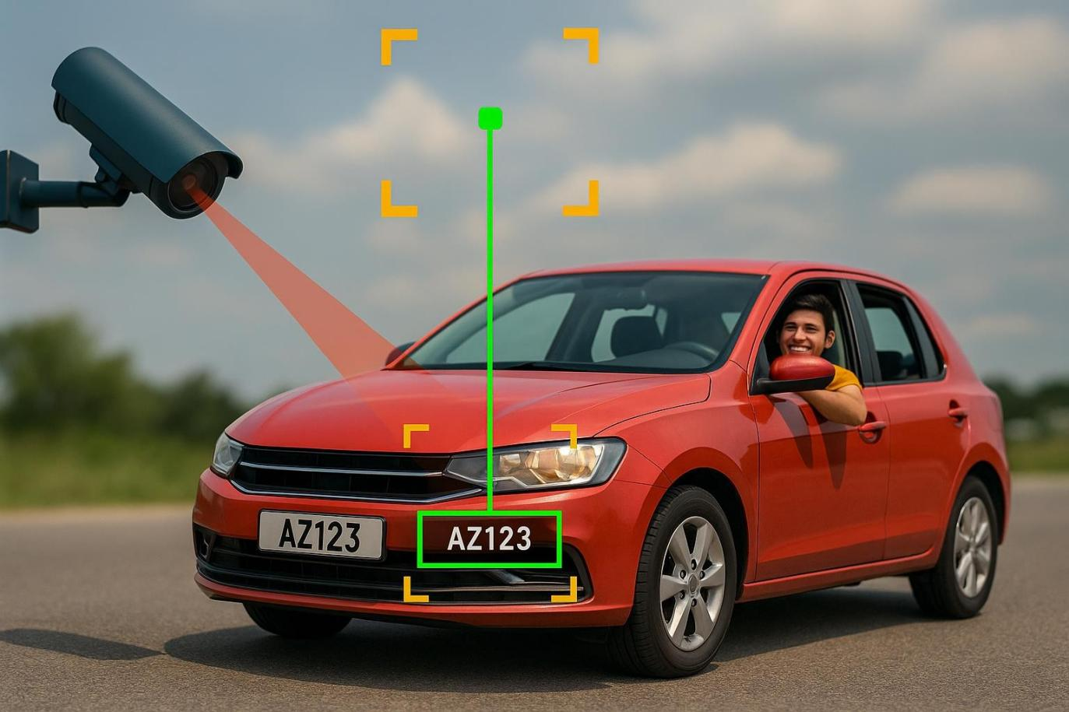

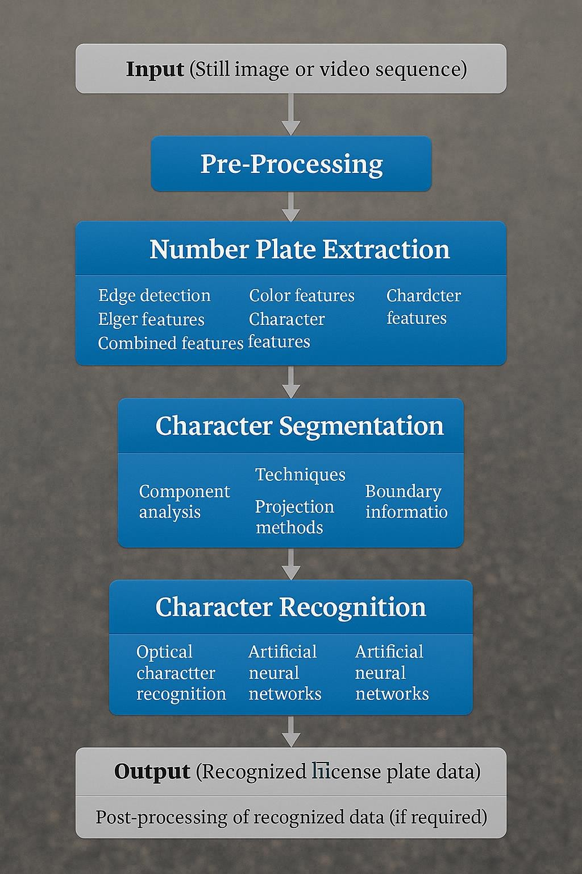

# Methodology

### Image Capture

The system initiates by acquiring video frames through a standard webcam or surveillance camera. These continuous video streams are analyzed in real-time to detect the presence of vehicles.

### Image Pre-processing

To enhance detection accuracy, several pre-processing steps are applied:-

**Grayscale Conversion:** Simplifies image data by removing color, focusing only on intensity values.

**Gaussian Blurring:** Reduces noise and smooths the image to improve edge clarity.

**Edge Detection:** Utilizes the Canny algorithm to highlight object boundaries, particularly useful for outlining number plates and vehicles.

### Detection and Filtering of Contours

**Contours Identification:** Contours are extracted from the processed edge map, identifying potential regions of interest.

**Aspect Ratio Analysis**: Rectangular contours with a shape similar to standard license plates are filtered using width-to-height ratio checks.

### License Plate Localization

After selecting the most suitable contour, the specific area containing the license plate is isolated from the rest of the image for further operations.

### Visualization and Output

**Drawing Bounding Boxes:** A rectangle is drawn around the detected number plate for easy visualization.

**Optional OCR :** The system can be enhanced by applying Optical Character Recognition to extract alphanumeric characters from the localized plate.

### Database Integration (Optional)

Recognized number plates can be logged or cross-checked with an existing database to enable functions such as stolen vehicle alerts or access control.

# System Implementation

The system implementation involves the use of OpenCV to process video frames, detect number plates, and display the results in real-time. Below is a portion of the code for this task.

import cv2

import numpy as np

# Initialize camera feed camera = cv2.VideoCapture(0)

camera.set(cv2.CAP_PROP_FRAME_WIDTH, 640)

camera.set(cv2.CAP_PROP_FRAME_HEIGHT, 480)

while True:

success, frame = camera.read() if not success:

break

# Resize and convert to grayscale

resized_frame = cv2.resize(frame, (640, 480))

gray_frame = cv2.cvtColor(resized_frame, cv2.COLOR_BGR2GRAY)

# Apply Gaussian blur to smooth the image

smooth_frame = cv2.GaussianBlur(gray_frame, (5, 5), 0)

# Detect edges using Canny

edge_frame = cv2.Canny(smooth_frame, 50, 200)

# Identify contours in the edge-detected image

contours, _ = cv2.findContours(edge_frame, cv2.RETR_TREE, cv2.CHAIN_APPROX_SIMPLE) top_contours = sorted(contours, key=cv2.contourArea, reverse=True)[:15]

found_plate = False

for contour in top_contours:

# Approximate the contour shape

polygon = cv2.approxPolyDP(contour, 0.018 * cv2.arcLength(contour, True), True) if len(polygon) == 4:

x, y, width, height = cv2.boundingRect(polygon) ratio = width / float(height)

if 2.0 < ratio < 6.0 and width > 120 and height > 30: found_plate = True

cv2.drawContours(resized_frame, [polygon], -1, (0, 255, 0), 2) cv2.putText(resized_frame, "License Plate", (x, y - 10),

cv2.FONT_HERSHEY_SIMPLEX, 0.7, (0, 0, 255), 2)

license_area = resized_frame[y:y + height, x:x + width] cv2.imshow("Detected License Plate", license_area) break

if not found_plate:

cv2.putText(resized_frame, "Scanning for Plate...", (20, 30),

cv2.FONT_HERSHEY_SIMPLEX, 0.7, (100, 100, 255), 2)

cv2.imshow("Live Plate Detection", resized_frame)

# Exit on pressing 'q'

if cv2.waitKey(1) & 0xFF == ord('q'): break

camera.release()

cv2.destroyAllWindows()

# Output



**Result**

Once deployed, the system effectively detects and extracts license plate numbers from real- time video streams. By incorporating state code mapping, it instantly identifies the vehicle’s state of registration. The live display interface ensures user-friendly monitoring and easy

verification.

Evaluation results show strong performance, with high accuracy in identifying plates and recognizing characters across diverse lighting conditions. Its consistent reliability makes the system well-suited for use in traffic surveillance, security enforcement, and automated entry control systems.

# Conclusion

The implemented ANPR system efficiently overcomes the limitations of manual vehicle identification. Leveraging the capabilities of OpenCV and Tesseract OCR, it delivers real-time and precise license plate recognition along with state code detection. Its flexibility across varying environmental conditions and potential for scaling make it a strong asset for

contemporary traffic management and security systems. Future improvements could involve linking the system to vehicle databases for verification purposes and incorporating machine learning techniques to enhance detection accuracy and processing efficiency.